MECE-606 Systems Modeling Project

May 3- 10, 2016, Rochester, NY, USA

**Fluid Tank Model**

**Guilherme Mollica**

Department of Mechanical Engineering

Rochester Institute of Technology

Rochester, NY 14623

Email. ghg3352@rit.edu

**ABSTRACT**

The behavior of thermal dynamics of fluid tank is modeled based on the output data and the pressure drop, orifice area, and flow resistance. The convection coefficient values of R in laminar mode, Cd in Bernoulli mode and k and m in Empirical mode are measured estimating the better fit with the output data. The three different models are used in this lab to compare against each other.

**INTRODUCTION**

The two tank leveling systems are set up as below.

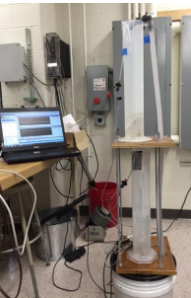

Figure 1. The setup of Two tank systems

There are three models to be considered.

$q=\frac{1}{R}∆P$ Laminar

$q=C_{d}A_{0}\sqrt{\frac{2∆P}{ρ}}$ Bernoulli

$q=k{\left(∆P\right)}^{m}$ Empirical

**Zeyar Win**

Department of Electrical Engineering

Rochester Institute of Technology

Rochester, NY 14623

Email. zxw6805@rit.edu

The two cylinders are put as column set each with a threaded orifice as seen in figure 1. The nozzles of the different diameters can be screwed into the tank to constraint the flow of fluid by tapping the orifices. The flow rate of water is varied changing v command voltage. The three dynamics models are programmed in this project with the continuity equation and various sets of orifice flow.

**ANALYSIS**

There are three different cases being taken into consideration to model the tank fluid system.

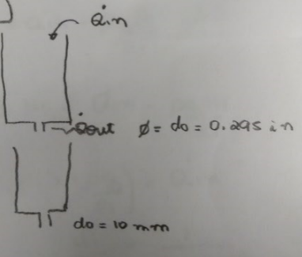

Figure 2. Schematics of the system

For all cases, $A_{1}H_{1}^{'}=Q_{in}^{'}-Q_{out}'$

From the schematics of the system, first order Laminar case is derived as below. The top tank and bottom tank rising water data are cut since only the flow rates out of the tank are taken account into calculation.

$$AH_{1}^{'}= -\frac{ρg}{R_{1}A}H_{1}$$

Similarly, $AH_{2}^{'}= -\frac{ρg}{R_{2}A}{ H}_{2}$

Since $\frac{1}{τ}=\frac{ρg}{RA}$, R can be calculated after the time constant is obtained from the step response of the system. The time constant of the top tank is found to be 6.6 secs and that of bottom tank is 8.5 secs. The value of R1 is 12.88e6 and that of R2 is 16.5889e6.

The first order case state space is as below. $$\left[\begin{aligned}H_{1}' \\ H_{2}' \end{aligned}\right]=\left[\begin{aligned}-\frac{ρg}{R_{1}A_{1}} 0 \\ \frac{ρg}{R_{1}A_{2}} - \frac{ρg}{R_{2}A_{2}} \end{aligned}\right]\left[\begin{aligned}H_{1} \\ H_{2} \end{aligned}\right]+\left[\begin{aligned} \\ \frac{K}{A_{1}} \\ 0\end{aligned}\right]\left[Volt\right]$$

The second order case is non-linear case and thus cannot use state space form to simulate. The Simulink is used to simulate Bernoulli case while the ODE45 function is used in the empirical case.

The second model case equations are as below.

$A_{1}H_{1}^{'}=Q_{in}^{'}-CD_{1}A_{0}{\left(\frac{2ρgH_{1}}{ρ}\right)}^{\frac{1}{2}}$

$$A_{2}H_{2}^{'}=CD_{1}A_{0}{\left(\frac{2ρgH_{1}}{ρ}\right)}^{\frac{1}{2}}-CD_{2}A_{0}{\left(\frac{2ρgH_{2}}{ρ}\right)}^{\frac{1}{2}}$$

The third model is derived as below.

$A_{1}H_{1}^{'}=Q_{in}^{'}-K_{1}{\left(ρgH_{1}\right)}^{m_{1}}$

$A_{2}H_{2}^{'}=K_{1}{\left(ρgH_{1}\right)}^{m_{1}}-K_{2}{\left(ρgH_{2}\right)}^{m_{2}}$

**SIMULATION**

The three cases of fluid top tank are simulated as shown in figure 3.



Figure 3. The simulation of top tank in three models

When water is rising in bottom tank, there is no flow out of bottom tank like top tank case. The bottom tank is simulated as in figure 4.



Figure 4. The simulation of bottom tank in three models

Static gain for top and bottom is found from the slope of the equation as in figure 5.

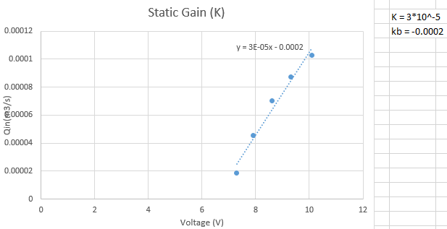

Figure 5. Static gain plot

From the simulation as figure 3 and 4, the R laminar flow resistance, C discharge coefficient and empirically determined coefficients k and m as in table 1.



Table 1. The coefficient values of three cases

The RMS values are obtained as in table 2. Case 1 linear case is the worst among the three flow models. Empirical case is slightly better than Bernoulli case.



Table 2. The RMS values of 3 cases simulation

The cost function of second case can be seen in figure 6.



Figure 6. The cost function of Bernoulli case

The validation data sets are simulated as in figure 7 to 10.

Figure 7. The validation data set 1 of top tank



Figure 8. The validation data set 1 of bottom tank

Another sets of validation data are used to simulate and observe the dynamic behavior of Tank Fluid system. Even though the coefficient values of case 2 and 3 are perfectly fit with the validation data, the dynamic models of all cases don’t match well with the real flow rate. This behavior can be observed in figure 9 and 10.



Figure 9. The validation data set 2 of top tank



Figure 10. The validation data set 2 of bottom tank

The RMS values of validation data sets 1 and 2 are shown in table 3. The linear case is the worst case and flow rate doesn’t have good accuracy. The case 3 Empirical is the best match among three models since it has lowest RMS values.



Table 3. The RMS values of validation data sets 1 and 2

**CONCLUSION**

The lab objective was achieved using the three different fluid differential equations, finding coefficient values such as R, Cd, k and m through trial and error, and plotting those in two validation data sets. The validation data sets are similar to the real output data as seen in figure 6 to 9 for top and bottom tanks. To conclude, the lab is successfully completed utilizing Matlab state space modeling and Simulink.